Scouting Forms

Troop 444 Phone Policy
Technology continues to evolve and become more embedded in every part of our lives. Rather than ban its use in scouting, we’ve chosen to find a way to make it available. This can only work if everyone commits to following the guidelines. This is a good example of a scout being “obedient” and “courteous” for the good of the group.
Phones are dangerous tools and are in many ways comparable to pocket knives. Thus they should be given the same respect as any knife! The following is just a few ways they compare:
- Both are tools. Both could be toys.
- Both can be used recklessly.
- Both can hurt people.
- Both can be highly useful.
- Both require training for proper use.
- Both can, at times, scare people.
- Neither is going away.

Scouts are not permitted to use cell phones or electronic devices during Scout meetings or while on activities in such a way that it interferes with the activity program. Use of cell phones or electronic devices is allowed as a privilege when they do not interfere with scouting activities or with the safety or the rights of others. YOU ARE NOT ALLOWED TO TOUCH ANOTHER’S PHONE WITH OUT THEIR PERMISSION, AND STRICTLY FOR SOUL PURPOSE IT WAS INTENDED FOR. THEY ARE NOT TOYS, AND BREAK EASILY.
The Scoutmasters and Senior Patrol Leader, will make all judgments on acceptable use of cell phones or electronic device use jointly. This policy is intended to reduce distractions during meetings and activities, to encourage the development of interpersonal skills, and to promote team-building consistent with the Scout Spirit.
To help you remember what is appropriate and what isn’t just think of the Scout Law before you use your phone/electronic device next time.

Trustworthy
- A Scout is truthful with others online and is careful of the information shared.
- He does the right thing when sharing and makes sure to have permission to share the words or pictures of others.
Loyal
- A Scout uses his phone or device in a way that adds to his troop or patrol.
- A loyal Scout is careful to post only appropriate photos or clips and would never want to embarrass others with his updates or communication.
- A loyal Scout would not use a phone to exclude some Scouts from the conversation, for example with secret messages.
Helpful
- A Scout could use applications that can add to the outdoor experience, such as a star-map, first aid or GPS.
- A Scout should alert others to scams, cheats, and suspicious sites and point them to reliable sources of information. Encourage people to report bad online behavior.
- A Scout may use a phone to take appropriate photos of events or situations for the troop or for personal memories
Friendly
- A Scout could use his phone to assist someone else with information or access to communication.
- A Scout could use his phone to invite others to join Scouting or to remind his fellow Scouts of important events and activities.
Courteous
- Ringers and alert messages should be muted — beeps, rings, and recorded music take away from the outdoor and Scout experience.
- A device should not be a distraction. Scouts should pay attention to the program and fellow Scouts. In a program or troop situation, a Scout should avoid checking his phone for incoming messages or emails, unless messages related to the program are expected. Consider using “airplane mode” and wait to check at designated free times.
- A courteous Scout does not interrupt a conversation with others to stop and check for inbound messages. The courteous Scout focuses his attention on his personal interactions, such as conversations in which he is engaged.
- A phone should not be used to insulate a Scout from the outdoors or others. For example, a Scout should not use headphones during a Scouting activity. During a Scout outing a phone should not be used for entertainment such as playing solo electronic games, idle web surfing, shopping, etc.
- A phone should not be used to play music or videos — for himself or for others — at an outdoor experience. Phone music at a campsite or campfire will take away from the outdoor experience for others.
Kind
- Not everyone can afford a smart-phone. A Scout needs to be sensitive to others and avoid using his phone in a way that looks like boasting and makes other Scouts disappointed that they cannot afford such a device. This is no different from any other piece of gear.
- A Scout always treats people with respect while on social networks, playing games, talking, texting or in other digital activities.
Obedient
- When using digital devices, a Scout follows the rules and examples set by parents, guardians, teachers, and Scout leaders.
- A Scout abides by the rules on websites, services, devices and games.
- A Scout is aware that different settings, events or locations will have different rules for use of electronics.
- If a Scout is asked to put their phone away by a member of leadership then they must abide to the rules. In the event that neither an adult leader or ASPL is present the Scout with the next highest ranking leadership position is in charge.
Cheerful
- A Scout uses games, messaging tools and social forums to build relationships with others while having fun.
Thrifty
- A Scout recognizes that his phone may run out of power, and learns to take measures to conserve power in his device such as by turning it off when not in use or by switching to “airplane mode” to conserve his battery.
- A Scout should not become overly reliant on his device. For example, a Scout should be ready with his map and compass rather than rely on his smartphone GPS.
- A Scout is a smart consumer. He knows his voice, text, and data plans and uses them wisely, careful not to run up charges on apps and sites.
Brave
- The Scout should not normally be calling home, or sending text messages back and forth with home. If the Scout thinks there is an urgent need to contact home, he should consult an adult leader first.
- Parents need to understand and agree that they are normally not to send messages or call their Scout while he is out with the program. Communication from home should be routed through an adult leader.
- Stand up for what is right. Do not participate in mocking or bullying others, even if others are doing it. Report suspected abuse to a trusted adult, like a parent or leader or call 911 as appropriate.
Clean
- A Scout uses clean language and only discusses appropriate topics when using digital devices to communicate with others.
- A Scout needs to take responsibility and take care of his device against damage from dirt, drops, water or other hazards. He may want to keep it carefully packed away against damage. He keeps his gear in good, working order.
Reverent
- A Scout respects the feelings of other people and would never use digital devices to spread irreverent ideas.

When can I use my phone?
- Before or after the 7:00p.m - 8:30p.m. Wednesday meeting
- On the way to and from Scout outings
- During down time or leisure time to play music
- As a camera
- Emergency tool: compass, GPS, contact, etc.
- On an outing an hour before lights out through a half hour after lights out
Ex. Lights out is at 10:30 PM so you can use your phone/electronic device from 9:30 PM until 11:00 PM
When can’t I use my phone?
- During meetings
- During planned scout activities, i.e. during an advancement outing while classes are being taught. If activities are scheduled from 9 AM to 3 PM, all phone use is prohibited, even if you are not teaching.
What are some examples of inappropriate phone use?
- Use of a phone during unsanctioned free time
- Watching or reading websites and videos with explicit content(images, writing, language)
- Sending or posting pictures of others that are inappropriate. Sending or posting pictures of others that they do not want to be posted
- Watching any sexual content will not be tolerated
- Poor language on the phone, or through text messaging
What is an example of appropriate phone use?
- Phone use as a tool for things that can’t be improvised (camera, GPS, contact system, watch, timer, etc.)
- Music playing during appropriate times

How will we regulate this? 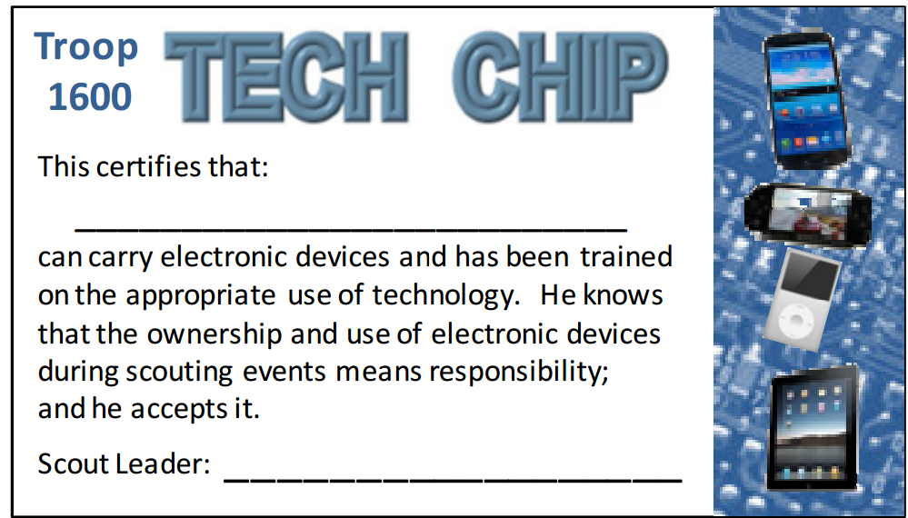
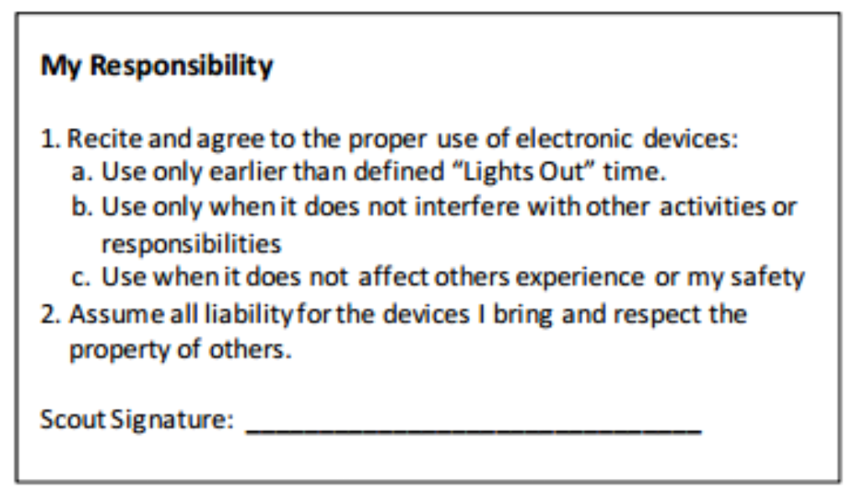
We have decided to regulate and keep track of who does their part to abide by these guidelines through a “Tech Chip.” The “Tech Chip” will be a simple, easy to use card similar to your Totin Chip. In order to use your phone/electronic device you MUST have your Tech Chip on your person. Failure to comply with this rule forfeits any of your electronic privileges on the next outing YOU ATTEND. Also, failure to comply with any of the rules specified above will result in a corner being cut from your tech chip. If all four corners are ever removed then you will lose your electronic privileges for the next two camping trips you attend. The “Tech Chip” is not to be taken lightly, the rules will be enforced. Also the consequences stated above will be given if you fail to follow the rules of the “Tech Chip”. Please use your phone responsibly, we do not want to have to take a corner off of your “Tech Chip”.
FINAL NOTE: IF YOU BRING A CELL PHONE TO A MEETING OR ON A TRIP, IT IS YOUR RESPONSIBILITY, LOST STOLEN OR DAMAGED.

https://docs.google.com/document/d/1ptO-rscifu6L07Xw0zMrOYgcGur_bZCzIOSrq5HoCpI/edit?usp=sharing
If parents or guardians need to contact their Scouts during a trip or event, they can call the cell phone of the adult leader in charge of the event.
Adult Phone Numbers:
Mr. Steve Gallatin (SM) – 443-277-6743
Mr. John Bauerle (ASM) – 410-591-4558
Mr. Morrison Pan (ASM) – 443-921-6801
Mr. Bob Reiners (ASM) – 443-386-9237
Mr. Scott Hinson – 410-591-8464

